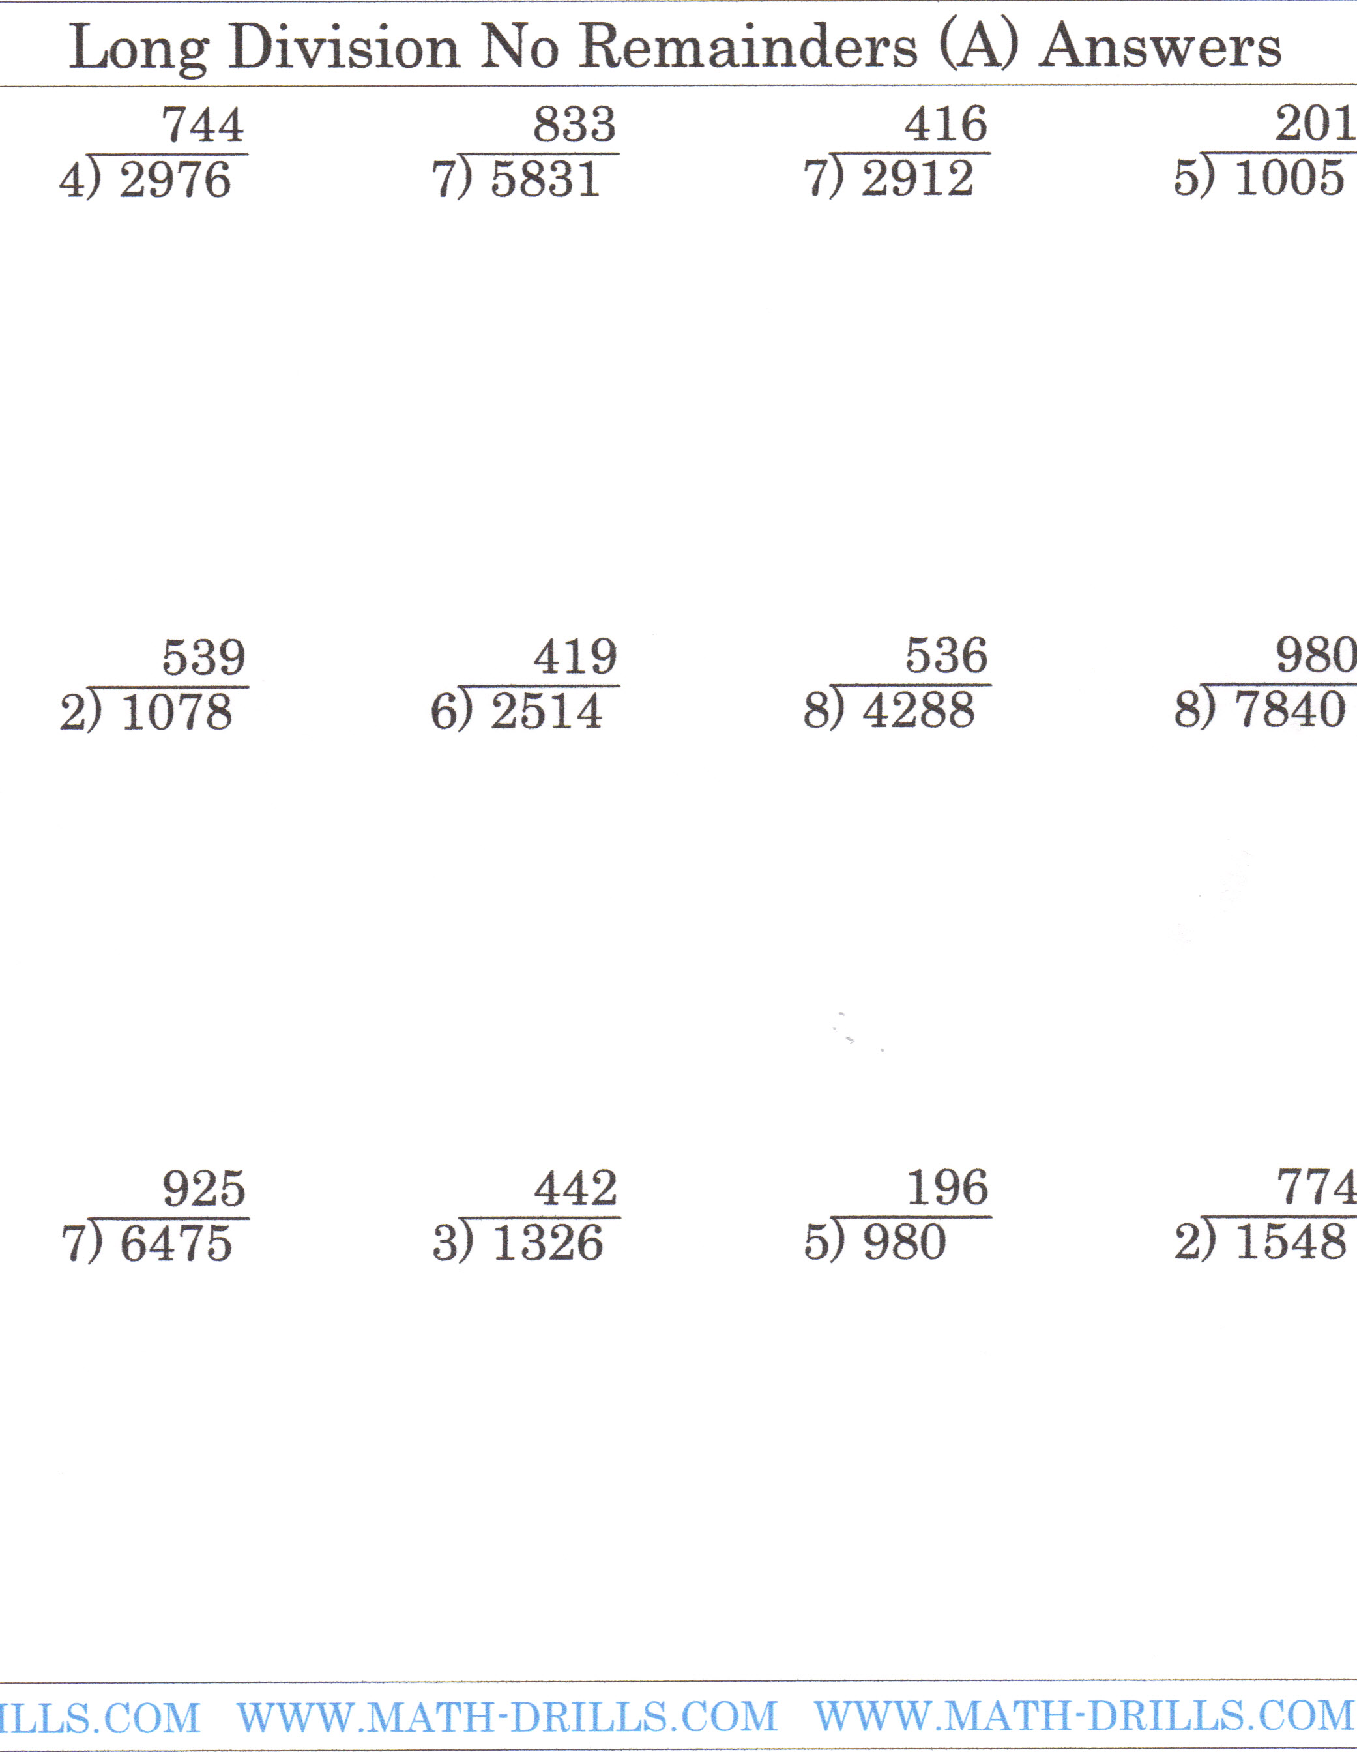
Answer Key: Long Division No Remainders A:

Answer Key: Long Division No Remainders B:
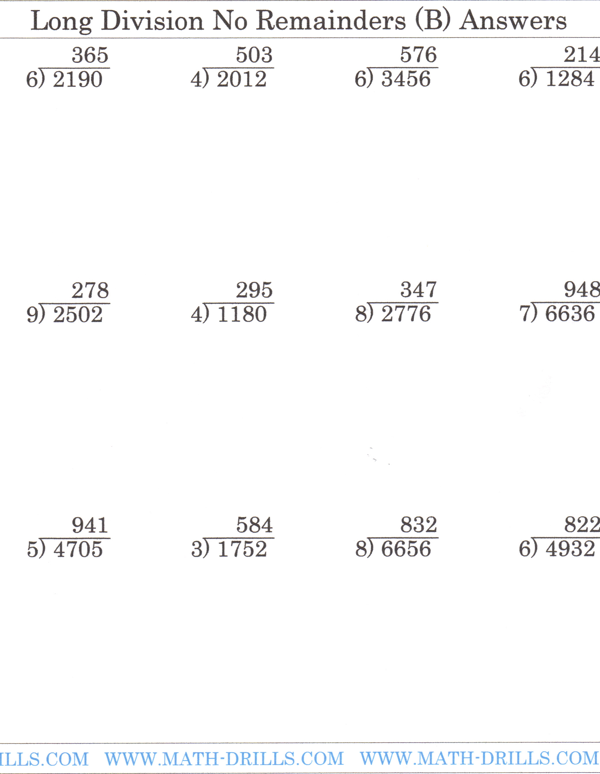

Answer Key: Long Division with Remainders A: 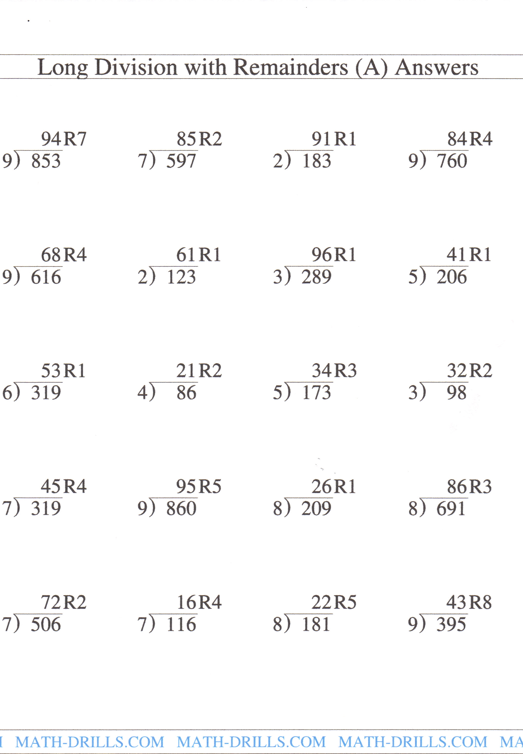

Answer Key: Long Division with Remainders B:
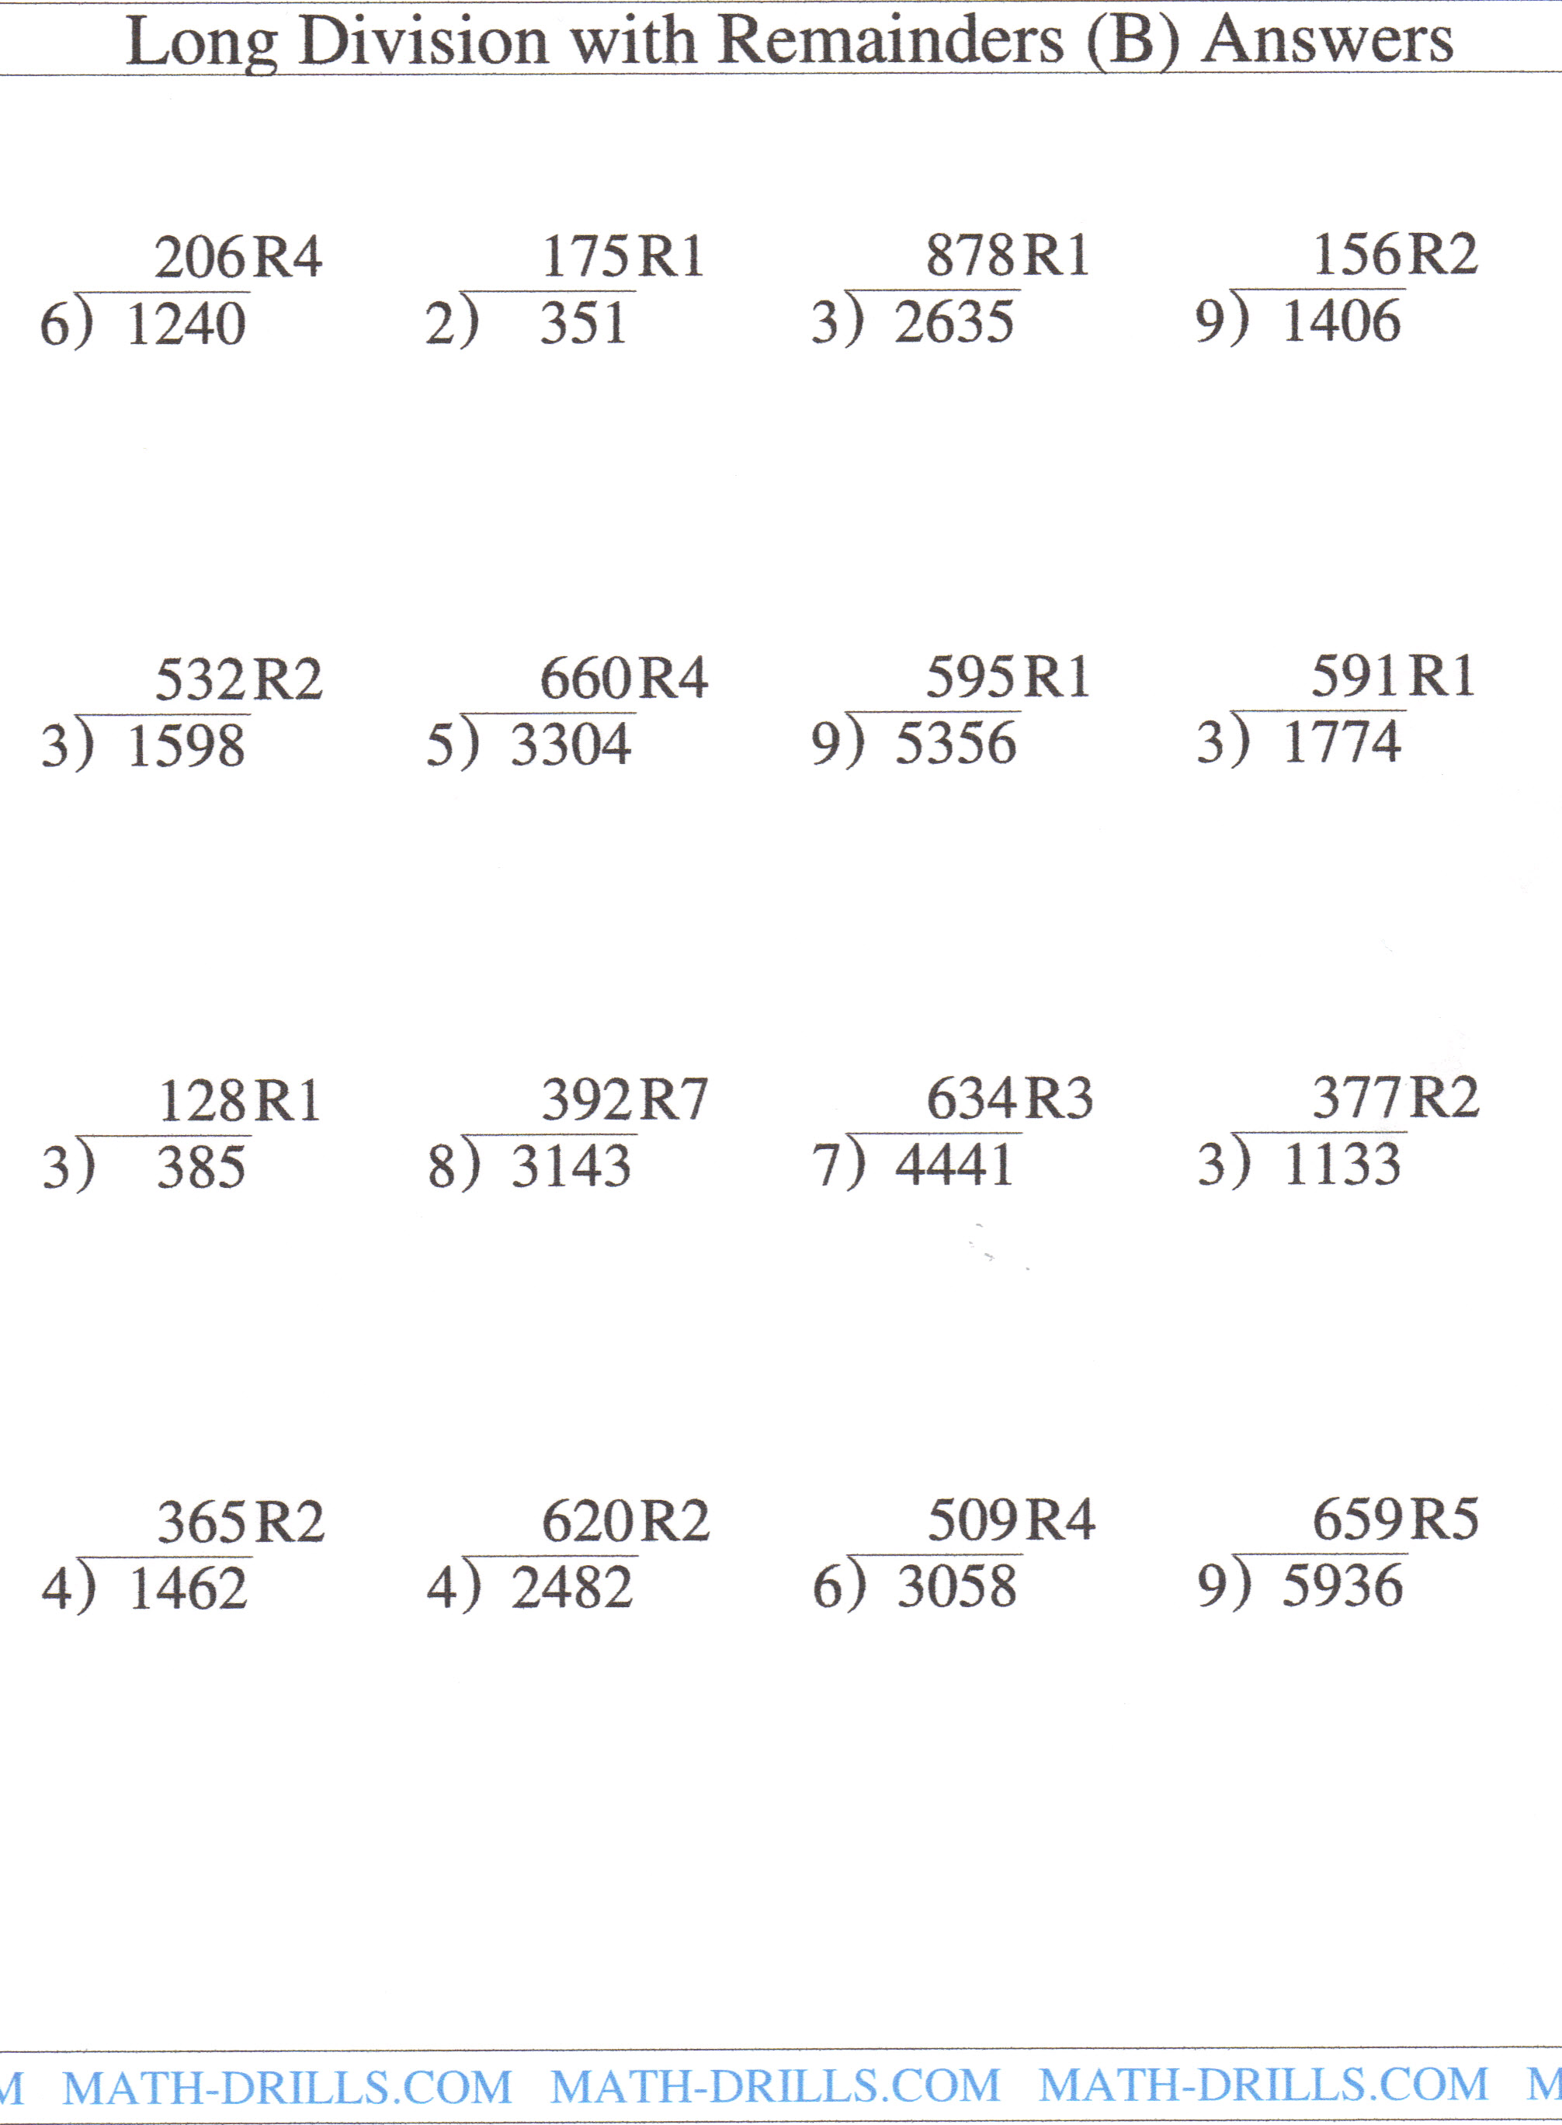

Answer Key: Sample Word Problems:
- 91 baskets
- Since the answer is 9 remainder of 1, they will need 10 buses to get everyone to the game.
- Each child should get 33 cookies with 3 cookies left over.
- 625 cats
- 848 people traveled by bus.

